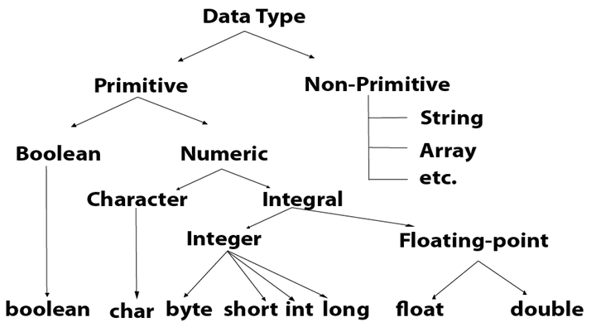

**Byte**

Size = 1 byte = (8 bit)

Max value = +127

Min value = -128

Range = -128 to + 127

Ex:

byte b = 10;

byte b = 127;

byte b = 128;

byte b = 10.5;

**Short**

Size = 2 byte =(16 bits)

Range = -2(15) to 2(15)-1

[-32768 to 32767 ]

Ex:

Short s = 10000;

Short s = -5000;

**Int**

Size = 4 byte = (32 bits)

Range = -2(31) to 2(31)-1

[-2147483648 to 2147483647 ]

Ex:

Int a =100000;

Int b = - 200000;

**Long**

Size = 8 byte =(64 bits)

Range = -2(63) to 2(63)-1

Ex:

long l = 100000L;

long b = -200000L;

**Float**

Size = 4 byte

Range = -3.4e38 to 3.4e38

Ex:

float f = 234.5f;

**Double**

Size = 8 byte

Range = -1.7e308 to 1.7e308

Ex: double d = 12.3

**Boolean**

Size = NA

Range = NA

(true / false)

Ex: boolean b =true / false;

boolean b = 0; -🡪 CE

Boolean b = “false” --🡪 CE

Boolean b = True -🡪 CE

**Char**

Size = 2 bytes

Range = 0 to 65535

Ex: char c = ‘A’;